AN OPTIMIZED THREE-PHASE MULTILEVEL INVERTER TOPOLOGY WITH SEPARATE LEVEL AND PHASE SEQUENCE GENERATION PART
ABSTRACT
This paper presents an optimized, 3-φ, multilevel inverter (MLI) topology. The proposed system is derived by cascading the level generation part with the phase sequence generation part. Further, it can be operated at any required level depending upontheconfigurationofthelevelgenerationpart.Thus,forhigher level operation extra components are required at the level generation part only. Therefore, number of components required for the proposed MLI is lower than the conventional 3-φ MLI topologies for higher level operation. Further, the level generation part is shared by the three phases equally. This eliminates the possibility of phase unbalance. The working principle and the operation of the proposed MLI are supported with the simulation and experimental validations. Further, the proposed optimized MLI is also compared with theconventional 3-φ MLIs to prove its advantage.

BLOCK DIAGRAM FOR PROPOSED SYSTEM
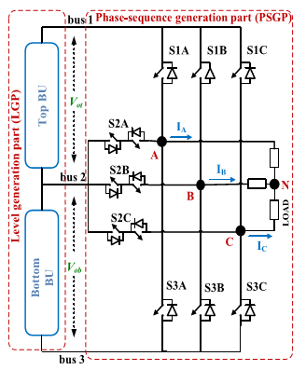
Fig. 1. Circuit schematic for the proposed m-level MLI.
DESIGNG SOFTWARE AND TOOLS:
MAT LAB /SIMULATION Software and simu power systems tools are used. Mainly control system tools, power electronics and electrical elements tools are used.

